**Project Charter**



**Revision and Signoff Sheet**

**Change Record**

|  |  |  |  |
| --- | --- | --- | --- |
| **Date** | **Author** | **Version** | **Change reference** |
| 09/12/2013 | Radu Cazacu | 1.0 | Initial draft for review/discussion |
|  |  |  |  |

**Approvers**

|  |  |  |  |
| --- | --- | --- | --- |
| **Name** | **Version approved** | **Position** | **Date** |
|  |  |  |  |

**Details**

|  |  |
| --- | --- |
| **Item** | **Details** |
| Document Title | Project Charter |
| Client | CAMERON TAUBATE |
| Project | OnBase Data Download & Notes for Rejection |
| Author | Radu Cazacu |
| Author Role | Project Manager |
| Author | Radu Cazacu |

**TABLE of Contents**

Contents

Change Record 1

TABLE of Contents 0

1 Project Purpose or Justification 1

2.1 General description of the existing document managment system 1

1.1.1 High Level Map 1

1.1.2 ITP File 2

1.1.3 Traceability Map – OnBase correspondence 2

1.1.4 NOI 3

1.1.5 Custom Query - SN: 112696396-01 query results (ANM-H CONECTOR 18-3/4" 3 HUB'S BCSS 2000 M) 3

2.2 General description of Issues 3

2 Project Description 4

2.3 OnBase Data Download Program 4

2.4 Notes for Rejection Report 4

3 High-Level Requirements 4

3.1 General Clarification Questions 4

3.2 OnBase Data Download Program 4

3.1.1 Assumtions 4

3.1.2 In project scope 5

3.1.3 Clarification of scope 5

3.1.4 Out of project scope 5

3.3 Notes for Rejection Report 5

3.1.5 Assumtions 5

3.1.6 Clarification of scope 6

3.1.1 In project scope 6

3.1.2 Out of project scope 7

4 High-Level Risks 8

5 Project Objectives and Success Criteria 8

6 Summary milestone schedule 8

7 Summary budget 9

8 Stakeholder list 9

9 Project Manager Authority Level 10

10 Technical Decisions 10

# Project Purpose or Justification

## General description of the existing document managment system

OnBase system is used in Taubate for quality document management system. A number of predefined documents are uses to capture supplier and manufacturer data.

Kofax is used to import document data and extract indexing information in keywords and E-forms are used for customer approvals.

A custom query is used to select all documents specific to 4104 plant.

Different methods and platforms are used during the data book creation process (Excel, Kofax, OnBase and Email communication).

### High Level Map

Below is the high level map of the current process showing different methods and platform used:

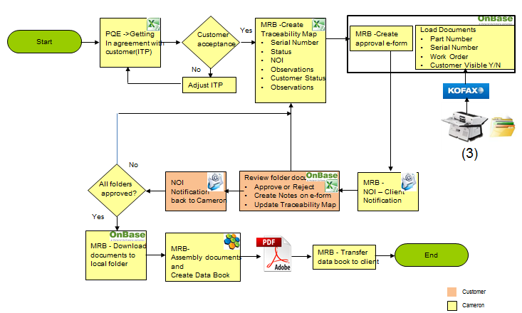

• PEQ – Project Quality Engineers are initiating the ITP file using BOM explosion and get the customer agreement regarding documentation required and holding points for the project. This communication is done through a shared excel file.

• MRB team uses the ITP file to create the Traceability Map file (adding a number of columns to keep traceability). This will be the shared file used in communication with customer once a serial number has been added and all documents are available for review in OnBase.

• Once all documents are ready for a specific serial number an e-form is released in OnBase for customer approval.

• In addition to this form a list (excel) with serial numbers is sent to customer.

• Customer review the list and run the OnBase custom query for each serial number. Depending on findings he can approve all documents or reject asking for additional documents or details.

• Once all documents for traceability map serial numbers have been approved these are manually (one by one) downloaded to a local folder.

• Next step is to assembly all these documents (Nuance) and create data book. As a rule, data book copy the product structure approved by PQE and customer at the initial phase with some additional cover sheets for each level items.

### ITP File

2 lines for each BOM part number. One with Cameron details specifying MS, QP, PSL and all the required certificates. Customer reviews the proposal and change / add additional requirements.

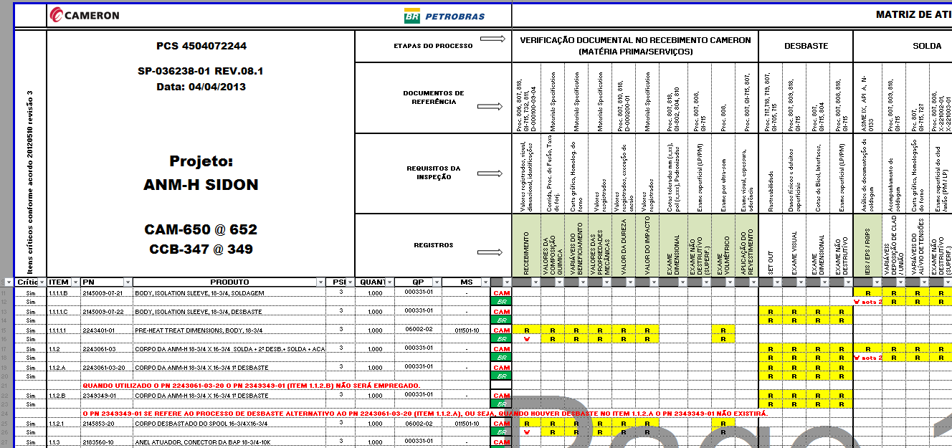

### Traceability Map – OnBase correspondence

MRB team change the layout and keep only the lines containing customer requirements. This file is shared with customer to get details about serial numbers used and execution process status (Cameron and customer)

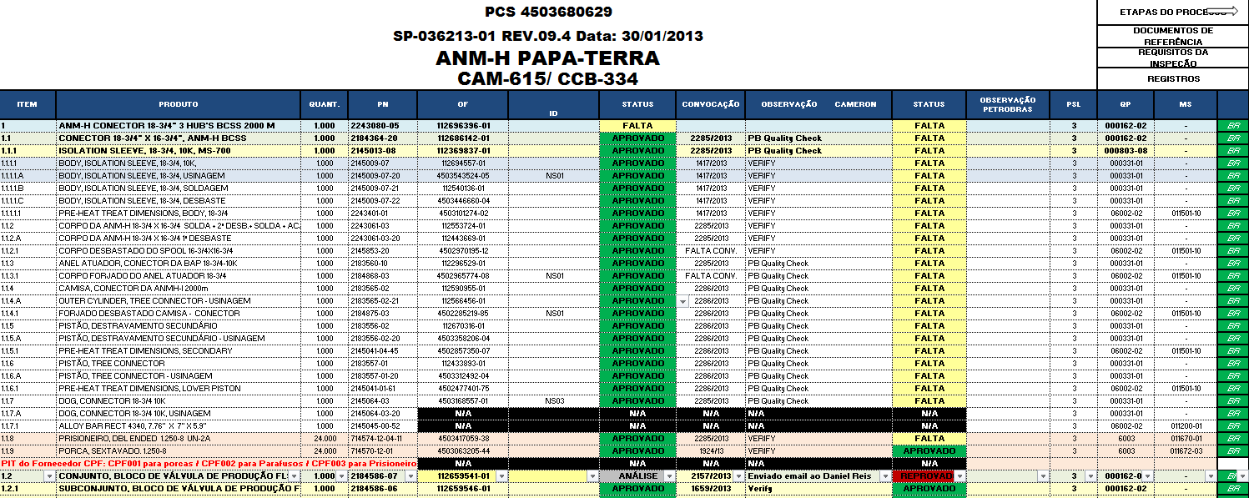

### NOI

When documents are ready e-form is released for documents approval and customer is notified by email (NOI form). A list with available serial numbers is attached for review.

Sample NOI:

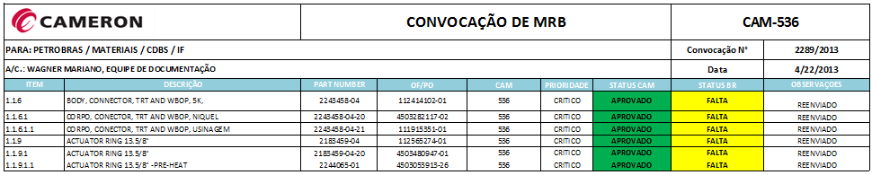

### Custom Query - SN: 112696396-01 query results (ANM-H CONECTOR 18-3/4" 3 HUB'S BCSS 2000 M)

Below is a query result for one specific serial number:

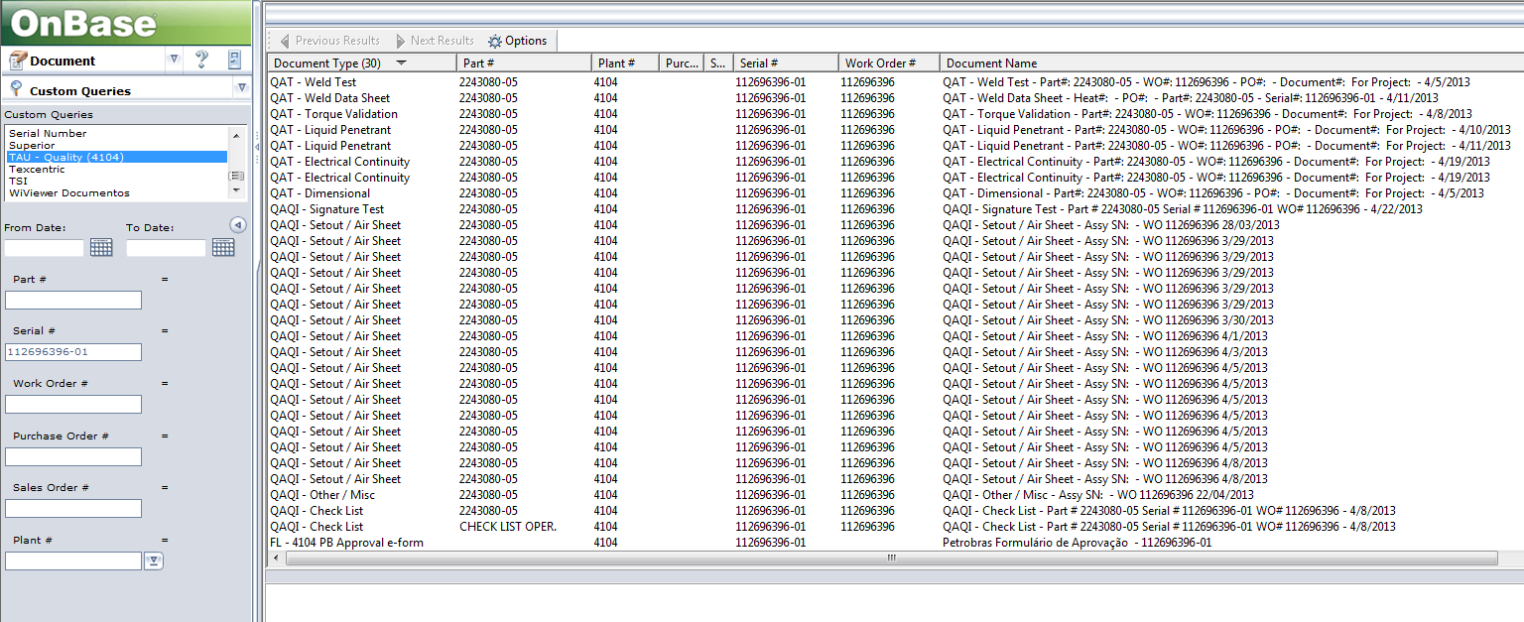

Different document types returned according with ITP file.

To minimize the number of QAI – Setout/Air sheet documents type a 6 sigma project has been started. This will decrease the number of these scanned documents associated with assembly parts and will put a better control on WIP.

## General description of Issues

Discussed with Quality management team and identified the following claimed issues described below.

|  |  |
| --- | --- |
| Issue | Description |
| Manual Extraction of Documents | Each OnBase documents is manually downloaded for further processing (data book). This is a time consuming process with several people working on it. |
| Notes for Rejections | No report or method available to automatically track the customer approval and Cameron reaction time to rejections. This adds additional time for data book |

# Project Description

This project addresses the issues described above to automate the operation processes.

## OnBase Data Download Program

An application to automate data extraction based on traceability map file maintained by MRB team. The proposed application will be configured to load on demand the Excel file, parse and extract the necessary information (part number, serial number, project code, product index), identify the OnBase documents and create the folder structure containing the exported documents.

## Notes for Rejection Report

A report to extract all the notes for each serial number from OnBase. The report should provide a number of selection criteria (project, list or serial numbers, only s/n with rejection notes, a specific time interval).

Report will be published on the existing Microsoft Reporting Services server

# High-Level Requirements

## General Clarification Questions

|  |  |
| --- | --- |
| **Question** | **Client answer** |
| Please specify version and build number of OnBase system | 10.0.0.93 |
| Please confirm existence of Unity API integration toolkit license and specify it’s version | Yes |
| Please confirm that this application will be windows forms (desktop) application |  |
| Please specify the windows operating system version (or versions) for the users workstations of this applications  (ex. Windows XP 32bit, Windows 7 64bit etc.) |  |
| Please provide us the testing environment access details. **Note:** This environment (OnBase system) must have the same structure and sample data as the production environment |  |

## OnBase Data Download Program

### Assumtions

* OnBase Unity API license exists and is installed on OnBase System.
* An OnBase test environment will be provided by the client for develop this application.
* The test environment can be accessed from supplier office remotely using VPN and/or Remote Desktop Connection software.
* The application will be installed by the client system administrator on each workstation following the provided installation procedure

### In project scope

Application input:

Traceability map file maintained by MRB team and described above.

Proposed application layout:

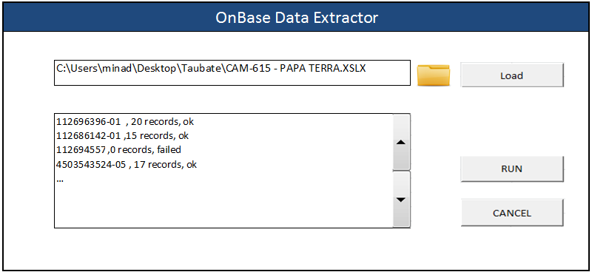

Proposed outputs for this application:

* A folder structure (similar with traceability map file). Planned convention name is level + serial number + part description. These folders will be populated with OnBase documents (API function used to get this data).
* A log file containing data extraction results. This file can be used to review results and correct errors.

### Clarification of scope

|  |  |
| --- | --- |
| **Question** | **Client answer** |
| For a project there will be one and only one Excel file ?  Ex. Do you need that for a project to export documents using two Excel Files | We use just one Excel file for each project (Equipment or CAM). We have many Excel files, but one for each project. |
| What Excel version will be installed on workstations ? | We use the Office Professional Plus 2010 |
| List all the columns from input file that will be used by the application. The rest of the columns will be ignored be the application.  This columns will always be in the same order ?  Yes. The columns will always be in the same order. | |  |  |  | | --- | --- | --- | | Column | Excel position | Purpose/Description | | ITEM | A |  | | PRODUTO | B |  | | PN | E |  | | OF | F |  | | SN | G |  | |
| What is the first line number for import ? | From line number 7 |
| Where will files be saved ? Export folder location will be a user selection ? | The Files will be saved in the desktop of the machine that log the program. |
| Application will access the OnBase system using provided user credentials or there will be a generic user configured for all application users ? | Everyone have their user credentials, When we logon on the intranet, we automatically logon on the OnBase |
| When the user selects to export documents of a project in a location where he already exported documents of that project the application will overwrite folders/files that already exists ?  Is this a common use scenario or an unlikely one? | Yes. This is a unlikely scenario. |
| For a line in the input document the application will export only one document or many documents from OnBase ? | Sometimes we export only one doc and sometimes we export many documents. |
| What is the unique indentifier (set of columns and keywnord correspondent) of documents corresponding to a line in the input file to be exported ? | The Column “F” is the keyword to find the documents on OnBase |
| What is the rule for naming the files ?  The unique identifier should be included in the name of the file | For search the documents on OnBase you just need copy the WO or PO filled in the column “F”, but to export the file I want the name file with this disposition: “Column A # Column F # Column B” almost like the picture below. |
| The project identifier in the input file will allways be in cell A4 ? | Yes |
| The following charaters are not permitted naming folder and files. Please provide a replacemend charater for each unpermitted charater.  We don’t’ use these characters | |  |  | | --- | --- | | Not permitted | Replace with | | \ |  | | / |  | | | |  | | : |  | | * |  | | ? |  | | “ |  | | > |  | | < |  | |
| The log will contain each processed line in the input file with an additional column containing the export result, is this the desired structure of the log ?  The log will be saved in the root of the export folder ? | Yes. |

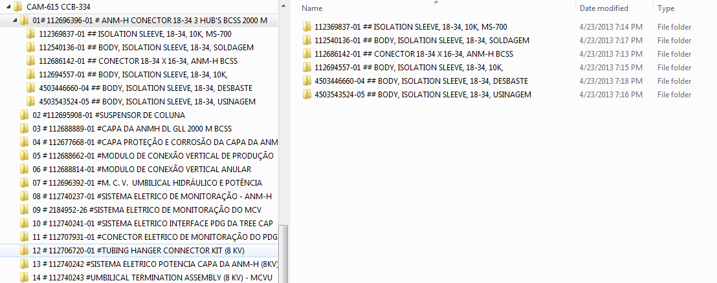

### Out of project scope

* The input file will not be processed by the application prior to import. The file must have the standard structure that will be agreed in the Analysis Document.
* Providing of the prerequisite components for this application (including necessary licenses) are not in the scope of this project. The application will use installed Microsoft Office Excel components to read the input file. The application will use OnBase API framework (Unity API) to access OnBase documents and keywords.
* The application will not validate OnBase data nor the output results. For example if a serial number is part of a project according to the input file but in OnBase the serial number correspond to another project the application will export according to the data present in the input file.
* The naming of the folders and files will be limited by the naming restrictions in the Windows operating system

## Notes for Rejection Report

### Assumtions

* A read access user to OnBase database will be provided for this report datasource.
* Microsoft Reporting Services is installed and fully configured to publish this report.
* Data volume will affect report performance. To increase report performance, users will run restrict data volume using the filter criteria provided.

### Clarification of scope

|  |  |
| --- | --- |
| **Question** | **Client answer** |
| The "Project name" parameter - for documents already imported into OnBase this parameter can not be used because it has no value, only if the existing documents are indexed again and value will be added for the Project name | OK |
| Serial number - What type of filtering is desired? For example, search by mask (ex: *430*) | Boolean search |
| The report is just for the notes on the document type "PL 4104 – Approval eform"? | Yes |
| Is the date interval necessary as a parameter ?  This applies to document create date or notes create date ? | Yes |
| Notes - Are there different types of notes ? | Yes (We use “note” and the Customer use “Rejected by PB”). |
| Date, date and time or time – only type parameter ? | Please clarify the question |
| Are the eform comments saved on keyword as well ? | Please clarify the question |
| There is only one keyword for comments or more values ​​(keywords) that must be concatenated? | Please clarify the question |

### In project scope

Once all required documents are added on serial number the approval e-form is started the customer is notified through NOI on email.

NOI sample:



Customer analyze all documents and decide to approve (all documents) or to reject the proposal creating a rejection note showing rejection reason, then return back the NOI file with Rejected status for the specific serial number.

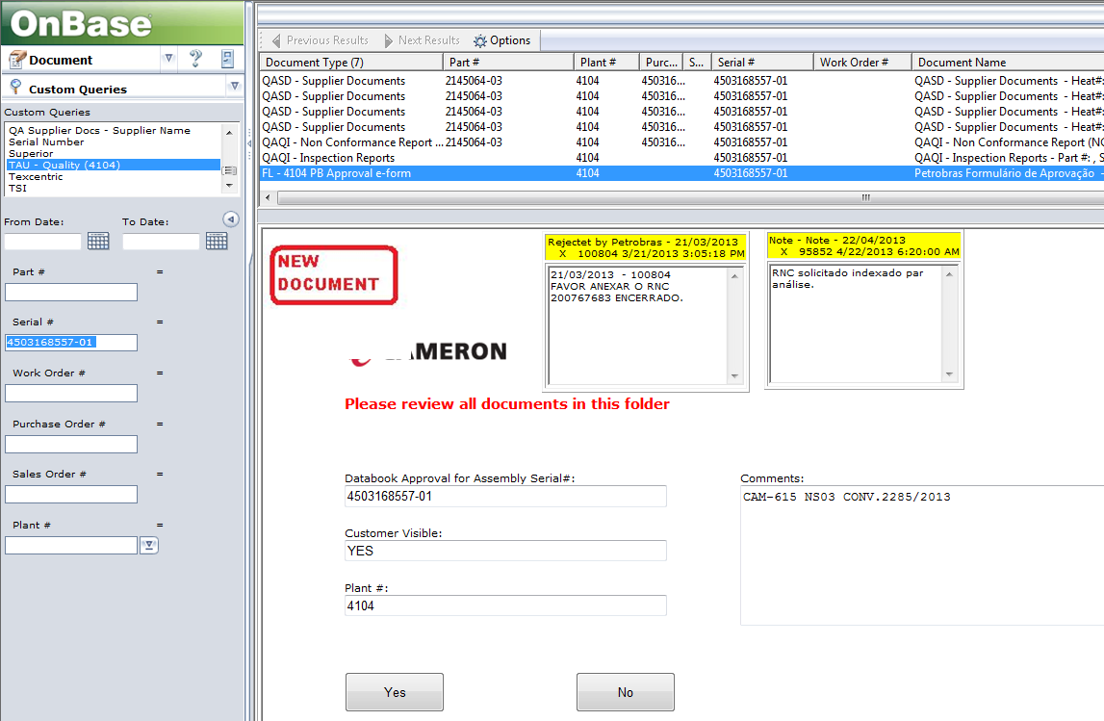

Input parameters:

The report should provide a number of selection criteria: project, list or serial numbers, only s/n with rejection notes, a specific time interval

Report output:

Running the report extracts all the notes for each serial number from OnBase. The report will be accessed using Internet Explorer browser version 8 or above. The report will not be accessible from OnBase.

Report output sample:

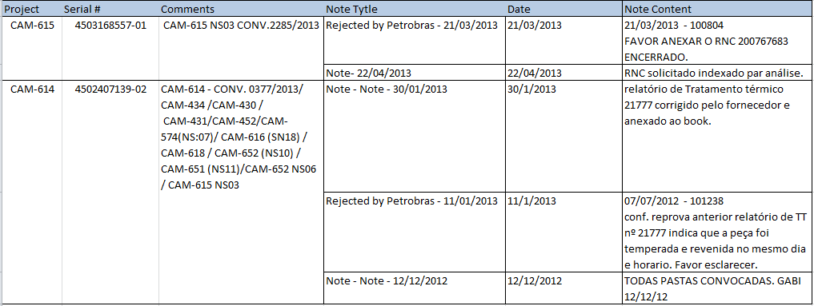

### Out of project scope

* Changes to the reports output template specified above.
* Project and Serial Numbers parameters will not support selection from a prepopulated list. They will support wildcards.
* Parameters are not dependent meaning one for example can select a serial number not appliable for the selected project(s).

# High-Level Risks

|  |  |  |
| --- | --- | --- |
| **Risk** | **Impact** | **Actions** |
| Infrastructure (workstations and server) requirements are not met | Can increase project costs and delay the Final Delivery | Communicate the infrastructure requirements for project deliverables.  Client prepares and upgrades the infrastructure to meet the requirements |
| Insufficient client resources for project’s client tasks including analysis, acceptance testing, system installation and training | Can delay the project phases and Final Delivery | Communicate the project plan, and review client’s tasks with the client responsibles.  Client allocates resources for the project. |

# Project Objectives and Success Criteria

High level project objectives are described in the table below.

|  |  |  |
| --- | --- | --- |
| **Project Objectives** | **Success Criteria** | **Person Approving** |
| **Scope** | | |
| OnBase Data Download Program | Application extracts data based on described input and outputs the project documents from OnBase to described folder structure on local machine. |  |
| Notes for Rejection Report | Custom report display all OnBase notes added for each serial number |  |
| **Time** | | |
| Final Delivery | Until 31.01.2014 |  |
| **Cost** | | |
| Total cost for the project does not exceeds | **20,075 EUR** |  |

# Summary milestone schedule

Below are the proposed due dates for the main phases of the project.

|  |  |
| --- | --- |
| **Summary Milestones** | **Due Date** |
| Approved analysis document | 20.12.2013 |
| Approved acceptance tests | 20.01.2014 |
| Key users trained | 24.01.2014 |
| Final Delivery (on production environment) | 31.01.2014 |

# Summary budget

The budget for the project is described in the table below.

|  |  |
| --- | --- |
| **Project Phase** | **Budget (EUR)** |
| Analysis | 2,200.00 |
| System Installation | 1,100.00 |
| Config & Development - 1. Extraction of Documents | 5,225.00 |
| Config & Development - 2. Report - Notes for Rejections | 2,200.00 |
| System Tests (30% of Config & Development) | 2,200.00 |
| Key Users Training | 1,100.00 |
| Prepare for GO Live | 1,100.00 |
| User Guide | 825.00 |
| Support GO Live | 2,200.00 |
| Project Management (10 % of all above) | 1,925.00 |
| **TOTAL** | **20,075.00** |

# Stakeholder list

Below is the list of people who have an interest and an influence on the project success.

|  |  |  |
| --- | --- | --- |
| **Stakeholder(s)** | **Position** | **Project Role(s)** |
| Radu Cazacu | Project Manager | Analysis, Project Management |
| Catalin Olaru | Application Consultant | Testing, System Administrator |
| Catalin Safta, Ana-Maria Ignat | Application Consultant | Development, Training |
| <to be completed> | <Client employee organization role> | <Client employee project role> |
| <to be completed> | ... | Sponsor |
| <to be completed> |  | Analysis |
| <to be completed> |  | Acceptance testing |
| <to be completed> |  | Client Project Management |
|  |  | System administrator (IT responsible) |

# Project Manager Authority Level

Project Manager from Matricia Solutions for this project is: Radu Cazacu.

Responsibilities of the project manager:

* Communicate with the project sponsor or client responsibles to approve project specific documents and procedures including analysis document, project plan and change management.
* Communicate project status to the project sponsor or client responsible
* Monitor and control project costs, timeline, scope and deliverables of the project

**Commercial terms**

* Contract to be sent by Matricia and signed by client
* Payment schedule
* Post implementation support